**Operating System Lab**

**Fall 2024**

**Lab 11 Task**



**Name: Ayesha Akhter**

**Sap id: 46508**

**BSCS-5**

**Lab Instructor:**

**Kausar Nasreen Khattak**

**Email:**

**kausar.nasreen@riphah.edu.pk**

**Lab Task**

**Note:** Include screenshots, where required to illustrate your explanation.

**Q1.** How do you create a basic for loop in a shell script to iterate over a list of numbers from 1 to 5?

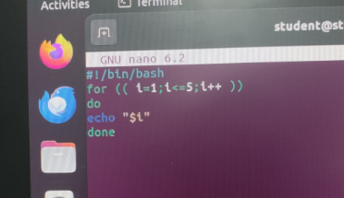

The for loop on the next line initializes a variable l at 1, increments it up to 5, and runs the loop for each value of l. Inside the loop, the echo "$1" command prints the first argument passed to the script ($1) for each iteration. The script will output this argument five times, once per loop iteration. Then after saving file all permissions are given and for output ./ with file name command is written.

**Q2.** What is the syntax for a while loop that counts from 1 to 10 and prints each number?

The variable count is initialized to 0, and the num is set to 10. A while loop then checks if count is less than or equal to num. If true, it executes the loop's body, where echo prints the current value of count. The let count++ line increments count by 1 in each iteration. This loop runs until the count exceeds num (10), at which point it stops.

**Q3.** How would you write a nested loop in shell scripting to print a multiplication table from 1 to 3?

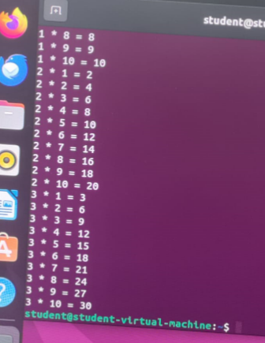

This Bash script uses nested loops to iterate over two variables, i and j. The outer loop runs three times (for values of i from 1 to 3), and the inner loop runs ten times (for values of j from 1 to 10). Inside the inner loop, the script calculates the product of i and j and stores it in the result variable. Finally, the echo command prints the values of i, j, and their product. This code effectively demonstrates how to use nested loops to create a multiplication table.

**Q4:** Write a for-in loop that iterates over the items in an array named fruits containing apple, banana, and cherry.

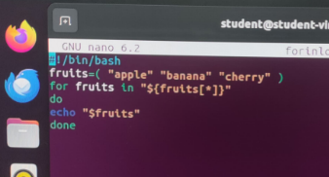

This Bash script defines an array named fruits and initializes it with three elements: "apple", "banana", and "cherry". The for loop iterates over each element in the fruits array. Inside the loop, the echo command prints the current fruit name onto the console.

**Q5:** Write a while loop that reads user input until the user types "exit".

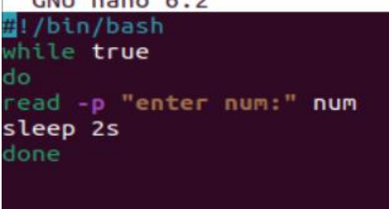

The user enters a number with the message "Enter num:". The user input is then stored in the variable num. This loop will keep taking Number from user until user exit from it.